ICS344 - Information Security – Section 4

Student Name(s) + ID(s):
Abdulwahab Badirah 202160410
Yazed almutairi 202164390
Abdulmuhaymin Althabit 202275600
Mohammed Alfaraj 202323090
DVSA Website URL:
AWS Region: N. Virginia (us-east-1)
Date: 5/3/2026
Vulnerability Title(s): Insecure Cloud Configuration

Goal and Vulnerability Summary
This lesson demonstrates an insecure cloud configuration vulnerability in the DVSA application. The affected component is the Amazon S3 feedback bucket (dvsa-feedback-bucket-701055076911-us-east-1), which is configured with public write access enabled. Because Block All Public Access is turned off, any unauthenticated actor can upload arbitrary files directly to this bucket without presenting any AWS credentials. Once a file lands in the bucket, an AWS Lambda function is automatically triggered to process it. The security impact is twofold: first, an attacker can inject malicious or attacker-controlled content into backend storage; second, the Lambda function processes that content without validating the file name or type, creating a path toward unintended code or command execution. The core weakness is a storage misconfiguration combined with an unsafe backend processing flow.

Why This Works / Root Cause
The vulnerability exists because the S3 bucket's Block All Public Access setting is disabled, and no bucket policy restricts write operations to authenticated or authorized identities. AWS S3 buckets do not block public writes by default unless explicitly configured to do so. Additionally, the Lambda function that processes uploaded objects performs no validation of the incoming file name, file type, or object origin before executing its logic. This means any file uploaded by anyone — authenticated or not — is treated as trusted input. The combination of an open bucket and a non-validating Lambda creates the full attack surface: unauthorized file placement leads directly to unauthorized Lambda execution.

Environment and Setup
- DVSA Website URL: http://dvsa-website-202164390-701055076911-us-east-1.s3-website.us-east-1.amazonaws.com
- Vulnerable S3 Bucket: dvsa-feedback-bucket-701055076911-us-east-1
- API Gateway Base URL: https://o9qhov9kt3.execute-api.us-east-1.amazonaws.com/Stage
- AWS Region: us-east-1
- CloudFormation Stack: serverlessrepo-OWASP-DVSA
- Tools used: AWS CloudShell, AWS CLI (s3, s3api, logs commands), AWS S3 Console, AWS CloudWatch Logs
- Account context: Standard IAM user with CloudShell access. The exploit itself uses no credentials (--no-sign-request flag).

Reproduction Steps
- Open AWS CloudShell in the us-east-1 region.
- Set the bucket name variable:
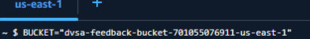
- Create a malicious payload file locally:
- Upload it to S3 with no authentication credentials:
- Observe the successful upload confirmation in the terminal output.
- Create a second file to further confirm open write access:

Evidence and Proof
- File upload succeeded
- Lambda function was triggered
- Initial behavior caused an error due to unexpected filename format
Screenshots:
Uploading a file:
Lambda is triggered:
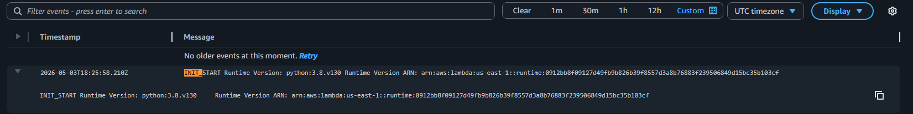

Block access is off:
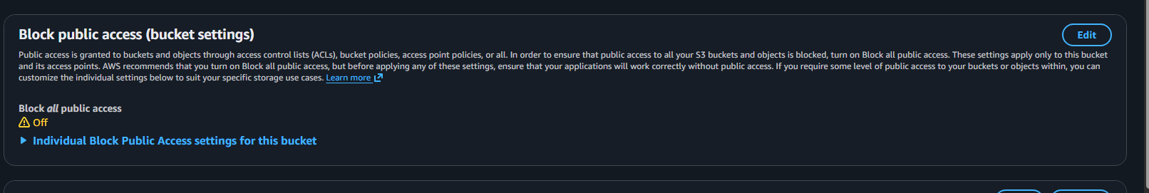
This shows that:
- The system processes user's files
- No validation was initially enforced

Fix Strategy / Probable Mitigation
The fix belongs at the S3 bucket permissions layer. The primary security improvement is to enable Block All Public Access on the feedback bucket, which prevents any unauthenticated or anonymous actor from writing objects regardless of bucket policies or ACLs. This directly addresses the root cause of open write access. As a defense-in-depth measure, the Lambda function should also validate uploaded object names and file types before processing them, and the bucket policy should restrict PutObject operations to only the intended authenticated principals. This applies the principles of least privilege, input validation, and defense in depth together across both the storage and compute layers.

Code / Config Changes
Resource changed: S3 bucket — dvsa-feedback-bucket-701055076911-us-east-1
Command applied in AWS CloudShell:
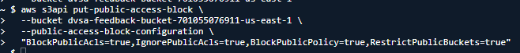
Before fix: Block all public access = Off (all four sub-settings disabled).
After fix: All four Block Public Access settings enabled:
- BlockPublicAcls = true blocks new public ACLs from being applied to the bucket
- IgnorePublicAcls = true ignores any existing public ACLs on the bucket and its objects
- BlockPublicPolicy = true blocks bucket policies that grant public access
- RestrictPublicBuckets = true restricts access to only AWS services and authorized users

Verification After Fix
After applying the fix, the same upload command was re-executed without credentials:
The unauthenticated upload now fails with AccessDenied. The Lambda function was not triggered. Legitimate authenticated users can still interact with the DVSA application through the normal frontend workflow, confirming that normal functionality is preserved after the fix.

Structured Operation and Security Analysis
Table 1: Structured analysis summary — Table A
Vulnerability | Intended Rule(s) | Artifacts Used to Infer Rule | Normal Behaviour Evidence | Exploit Behaviour Evidence
Insecure Cloud Configuration | Only authenticated, authorized users may write to the S3 feedback bucket. Uploaded content must be validated before Lambda processes it. Public unauthenticated writes must be blocked. | S3 Permissions tab (Block Public Access = Off); AWS CLI --no-sign-request test; CloudWatch INIT_START log; DVSA Lambda source showing no input validation. | Authenticated users submit feedback through the DVSA frontend. Lambda processes only expected, validated inputs. Unauthorized write attempts should be rejected with AccessDenied. | Unauthenticated CLI uploads of malicious.json and trigger.raw both succeeded. CloudWatch showed INIT_START at 2026-05-03T18:25:58.210Z confirming Lambda was triggered by attacker-controlled content.

Table 2: Structured analysis summary — Table B
Vulnerability | Why This Is a Deviation | Deviation Class | Fix Applied (Where) | Post-Fix Verification | Optional Latency Before / After Logging
Insecure Cloud Configuration | The intended rule requires authenticated writes only. The exploit bypassed this entirely using --no-sign-request with no identity verification. Lambda then processed attacker-controlled content, violating the authorization boundary at both the storage and compute layers. | Intentional Misuse / Security-Relevant Abuse | S3 bucket permissions layer: enabled Block All Public Access via put-public-access-block with BlockPublicAcls, IgnorePublicAcls, BlockPublicPolicy, and RestrictPublicBuckets all set to true. | Re-running the same aws s3 cp --no-sign-request command returned AccessDenied (PutObject). Lambda was no longer triggered. Legitimate frontend functionality remained intact. | No latency measurements taken. CloudWatch confirmed Lambda invocation before fix and no new invocations after fix.

Takeaway / Lessons Learned
The core security assumption that failed here was that an S3 bucket used as part of a backend processing pipeline would be protected by default. In reality, AWS S3 requires explicit configuration to block public access it does not enforce this automatically. In a serverless environment this is especially dangerous because S3 and Lambda are often tightly coupled: an object upload is all it takes to trigger backend code execution. This means a misconfigured storage layer directly translates into a code execution path for any unauthenticated user on the internet.
The general secure design principles that apply here are defense in depth and least privilege. Storage resources should be locked down to only the identities that genuinely need access. Compute resources such as Lambda should validate all inputs regardless of their origin, because storage alone is not a trust boundary. Had either control been in place independently bucket access restricted, or Lambda validating inputs the impact would have been significantly reduced. Together, both controls ensure the attack surface is minimized at every layer of the serverless pipeline.

